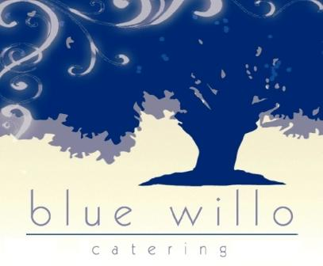

"This institution is an equal opportunity provider."



October Lunch 2024 NPP

|  |  |  |  |  |  |
| --- | --- | --- | --- | --- | --- |
| **Monday** | **Tuesday** | ***Wednesday*** | **Thursday** | **Friday** |  |
|  | 1 | 2 | 3 | 1 | **Cold available each day**  Caesar salad with or with out chicken  Assorted wraps  Assorted subs  Assorted croissant boxes |
| 7 | 8 | 9 | 10 | 11 | Hummus boxes  Bagel with cream cheese |
| 14  All beef sloppy joe  Mashed potatoes  Apples or oranges | 15  Chicken taco  Refried beans  Spanish rice  Lettuce/ salsa  Apples or oranges | 16 | 17  Pizza day | 18  Boneless chicken wings  4 way mixed vegetable  Dinner roll | **Hot available each day**  Pasta with sauce (v)  Pasta with mb  MB sub  Cheeseburger  Hamburger  Chicken Sandwich  Bacon Chicken Sandwich |
| 21  Popcorn chicken  Corn  Dinner roll  Apple or orange | 22  Chicken and waffles  Syrup  4 way mixed veg  melon | 23 | 24  Pizza day | 25  Burrito Bowl day  Beef or chicken  Apple or oranges |  |
| 28  All beef hot dog  Baked beans  Toppings of ketchup  Mustard  Apple or orange | 29  Bang bang chicken  Rice  Green beans  Melon | 30 | 31  Pizza day | 1  Tex mex burrito or bean and cheese burrito  Apple or oranges |  |